Spring Core and Maven

Exercise 1: Configuring a Basic Spring Application

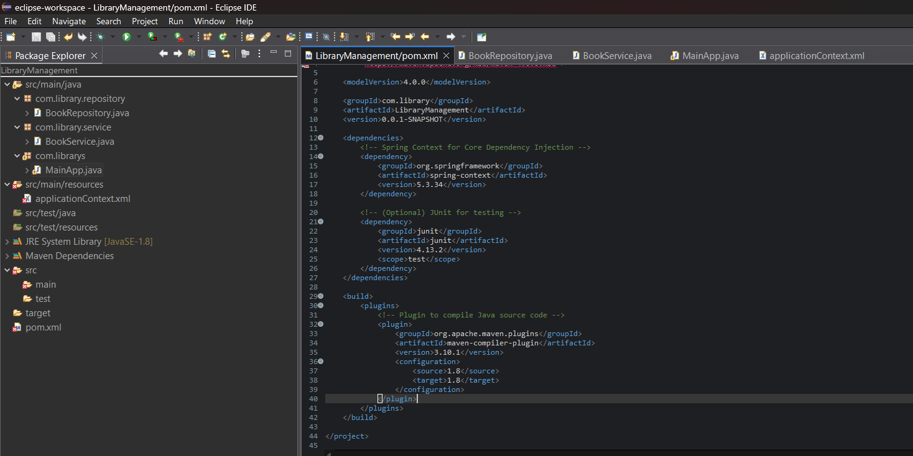
Dependencies to be added on pom.xml :
<dependencies>
<!-- Spring Core Dependency -->
<dependency>
<groupId>org.springframework</groupId>
<artifactId>spring-context</artifactId>
<version>5.3.34</version> <!-- Latest stable version -->
</dependency>
</dependencies>

applicationContext.xml :
<?xml version="1.0" encoding="UTF-8"?>
<beans xmlns="http://www.springframework.org/schema/beans"
xmlns:xsi="http://www.w3.org/2001/XMLSchema-instance"
xsi:schemaLocation="
http://www.springframework.org/schema/beans
http://www.springframework.org/schema/beans/spring-beans.xsd">
<bean id="bookRepository" class="com.library.repository.BookRepository" />
<bean id="bookService" class="com.library.service.BookService">
<property name="bookRepository" ref="bookRepository"/>
</bean>
</beans>

BookRepository.java :
package com.library.repository;
public class BookRepository {
public void saveBook(String bookName) {
System.out.println("Book saved: " + bookName);
}
}

BookService.java :
package com.library.service;
import com.library.repository.BookRepository;
public class BookService {
private BookRepository bookRepository;
public void setBookRepository(BookRepository bookRepository) {
this.bookRepository = bookRepository;
}
public void addBook(String bookName) {
System.out.println("Adding book in service layer: " + bookName);
bookRepository.saveBook(bookName);
}
}

MainApp.java :
package com.librarys;
import com.library.service.BookService;
import org.springframework.context.ApplicationContext;
import org.springframework.context.support.ClassPathXmlApplicationContext;
public class MainApp {
public static void main(String[] args) {
ApplicationContext context = new ClassPathXmlApplicationContext("applicationContext.xml");
BookService bookService = context.getBean("bookService", BookService.class);
bookService.addBook("Psychology of Money");
}
}

OUTPUT :
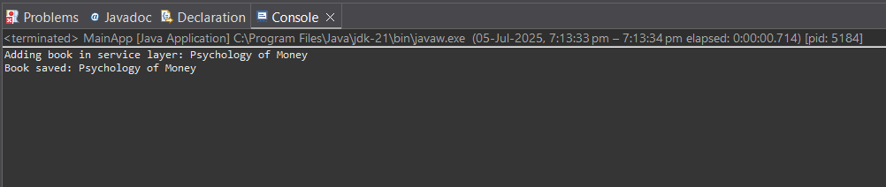

Exercise 2: Implementing Dependency Injection

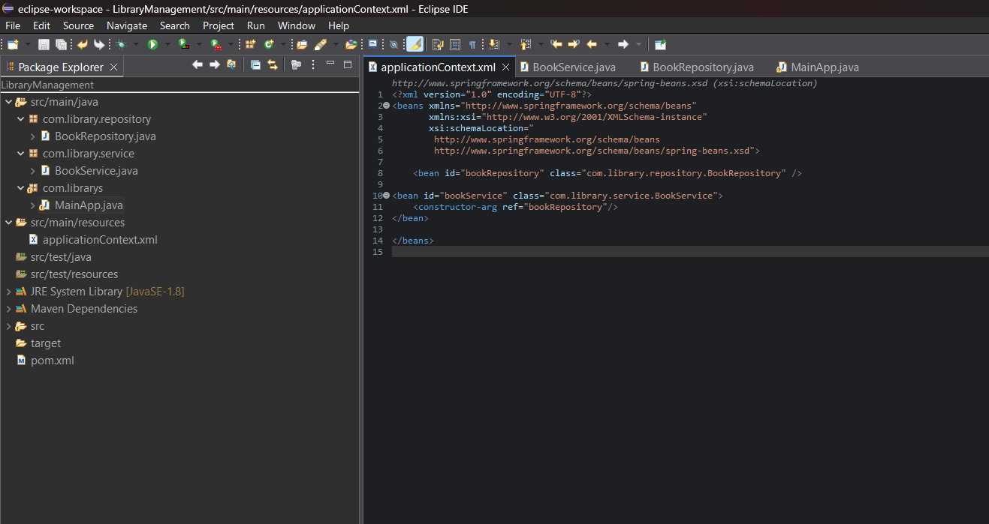
BookService.java :
package com.library.service;
import com.library.repository.BookRepository;
import org.springframework.beans.factory.annotation.Autowired;
import org.springframework.stereotype.Service;
@Service
public class BookService {
private final BookRepository bookRepository;
@Autowired
public BookService(BookRepository bookRepository) {
this.bookRepository = bookRepository;
}
public void addBook(String bookName) {
System.out.println("Starting book registration process...");
System.out.println("Verifying book: " + bookName);

if (bookName.length() < 3) {
System.out.println("Book name is too short. Cannot save.");
return;
}
bookRepository.saveBook(bookName);
System.out.println("Book \"" + bookName + "\" successfully added to the catalog.");
System.out.println("Process complete.\n");
}
}

BookRepository.java :
package com.library.repository;
import org.springframework.stereotype.Repository;
@Repository
public class BookRepository {

public void saveBook(String bookName) {
System.out.println("Saving book to repository: " + bookName);
}
}

MainApp.java :
package com.librarys;
import com.library.service.BookService;
import org.springframework.context.ApplicationContext;
import org.springframework.context.support.ClassPathXmlApplicationContext;

public class MainApp {
public static void main(String[] args) {
ApplicationContext context = new ClassPathXmlApplicationContext("applicationContext.xml");
BookService bookService = context.getBean("bookService", BookService.class);
bookService.addBook("Rich Dad Poor Dad");
bookService.addBook("AI");
}
}
OUTPUT :
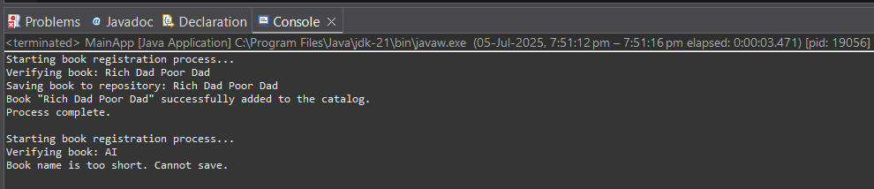

Exercise 4: Creating and Configuring a Maven Project

Dependencies to be added on pom.xml :
<dependencies>
<!-- Spring Context (core DI container) -->
<dependency>
<groupId>org.springframework</groupId>
<artifactId>spring-context</artifactId>
<version>5.3.34</version>
</dependency>
<!-- Spring AOP (optional, for cross-cutting concerns like logging) -->
<dependency>
<groupId>org.springframework</groupId>
<artifactId>spring-aop</artifactId>
<version>5.3.34</version>
</dependency>
<!-- Spring WebMVC (for controllers, DispatcherServlet, etc.) -->
<dependency>
<groupId>org.springframework</groupId>
<artifactId>spring-webmvc</artifactId>
<version>5.3.34</version>
</dependency>
<!-- Servlet API (required for Spring WebMVC apps, marked as provided) -->
<dependency>
<groupId>javax.servlet</groupId>
<artifactId>javax.servlet-api</artifactId>
<version>4.0.1</version>
<scope>provided</scope>
</dependency>
</dependencies>
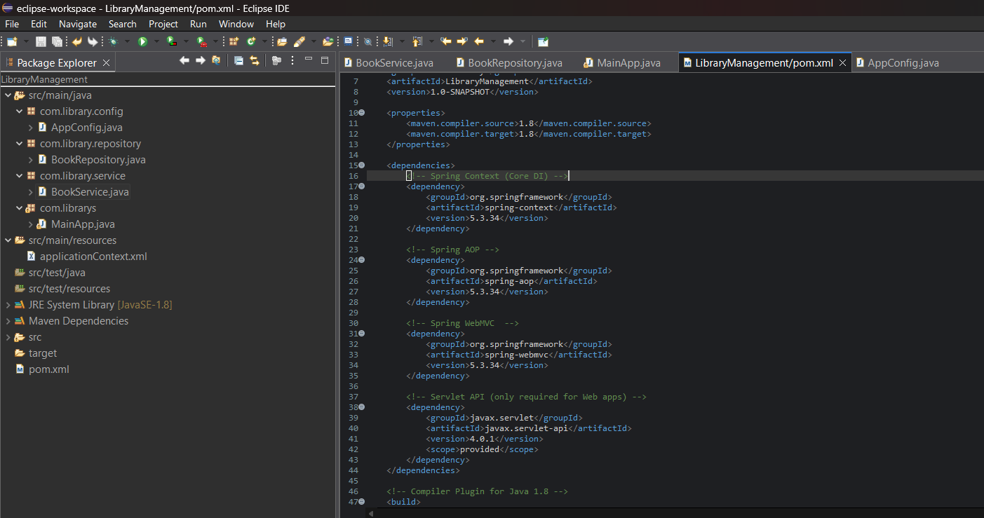
AppConfig.java :
package com.library.config;
import org.springframework.context.annotation.ComponentScan;
import org.springframework.context.annotation.Configuration;
@Configuration
@ComponentScan(basePackages = "com.library")
public class AppConfig {
}

BookRepository.java :
package com.library.repository;
import org.springframework.stereotype.Repository;
@Repository
public class BookRepository {
public void saveBook(String bookName) {
System.out.println("Book saved to repository: " + bookName);
}
}

BookService.java :
package com.library.service;
import com.library.repository.BookRepository;
import org.springframework.beans.factory.annotation.Autowired;
import org.springframework.stereotype.Service;
@Service
public class BookService {
@Autowired
private BookRepository bookRepository;
public void addBook(String bookName) {
System.out.println("BookService: Adding book -> " + bookName);
bookRepository.saveBook(bookName);
}
}

MainApp.java :
package com.librarys;
import com.library.config.AppConfig;
import com.library.service.BookService;
import org.springframework.context.ApplicationContext;
import org.springframework.context.annotation.AnnotationConfigApplicationContext;
public class MainApp {
public static void main(String[] args) {
ApplicationContext context = new AnnotationConfigApplicationContext(AppConfig.class);
BookService service = context.getBean(BookService.class);
service.addBook("The Psychology of Money");
}
}

OUTPUT :
